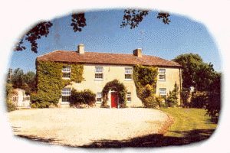
Eskermore House
Farmhouse Accommodation

In the heart of Ireland this early Georgian Farmhouse is set in the curve of a stream in wooded grounds surrounded by mature gardens.
The house has been modernized in sympathy with it's period and makes an ideal location for a holiday away from town and city where you can enjoy the tranquility of the surrounding area and the welcoming family atmosphere.


ITB approved Guesthouse.

Only 1 hour from Dublin airport and ferryports we are the ideal spot for you to relax away from the bustle of the city after a long trip and get into the relaxed laid back pace of life in the Irish countryside.
Our location in the heart of the country close to the major routes north, south and west makes us the ideal starting point for the rest of your trip to any part of Ireland.
Or if you want to have an alternative holiday in Ireland away from the obvious tourist destinations and sample a taste of the real Ireland have a look at some of the local attractions and get to see a whole different side to the country.
We can arrange a variety of activities for you including golf, horseriding, hunting and fishing.

How to find us

Eskermore House is located 7 miles (11km) from Edenderry town on the R402, the easiest way to reach us from Dublin is to follow the M4 as far as the Kilcock exit, take this exit and follow the signs for Enfield, turn left off the bypass of Enfield onto the R402 for Edenderry and from there follow the signs for Daingean and Tullamore, We are on the right hand side of the road and
you can't miss us.
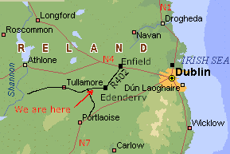

To contact us

Our address is:

Eskermore House,
Daingean,
Tullamore,
Co. Offaly,
Ireland.

Phone: +353 506 53079 or +868 8249574

You can visit our website to make a booking at:
www.eskermore.com

Or e-mail us direct at:

Ann@eskermore.com

